AICE Geography Review – Paper 2, Human Core

TOPIC 4: Population
4.1 - Natural Increase as a Component of Population Change
- Natural Increase Rate
  - Birth Rate – total # of live births per 1000 people in a year.
  - Death Rate – total # of deaths per year per 1000 people.
  - Fertility Rate – average number of children that would be born to a woman over her lifetime
  - Infant Mortality Rate – # of deaths per 1000 live births of children under one year of age
- Factors affecting level of birth/deaths/fertility/mortality:
- Social: In some societies, particularly in Africa, tradition demands high rates of reproduction, where the opinion of women may have little influence weighed against intense cultural expectations. Also, many women do not receive the proper education, causing them to have children at a young age. In addition, Muslim and Roman Catholic religions oppose artificial birth control.
- Economic: Children are seen as an economic asset because of the work they do in less developed countries. In HICs, the cost of raising a child is a major factor in deciding to have one. However, economic growth allows greater spending on health, housing, nutrition, and education, which is important in lowering mortality and reducing fertility. Also, many companies do not provide workplace childcare and do not offer the opportunity of flexible working time.
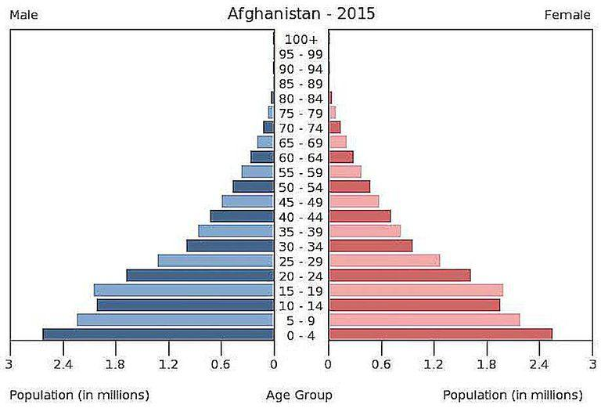
- Political: In the 1930s, Germany, Italy, and Japan all offered inducements and concessions to those with large families. However, most governments want to reduce population growth. For example, China had adopted 1-child policy where a family was only allowed to have one child.
    - Afghanistan is a Stage 2 country, where they have a high birth rate due to their population being highest aged (0-4). However, they have a short life expectancy due to lack of medical and technological development.

- Population structure:
  - Dependency Ratio – the relationship between the working or economically active population and the non-working population.
  - Formula for calculating the dependency ratio:
  - Youth dependency ratio = % population aged 0-14 + % population aged 65 and over / (% population aged 15-64)

  - Demographic Transition
- Why do birth and death rates change over time?

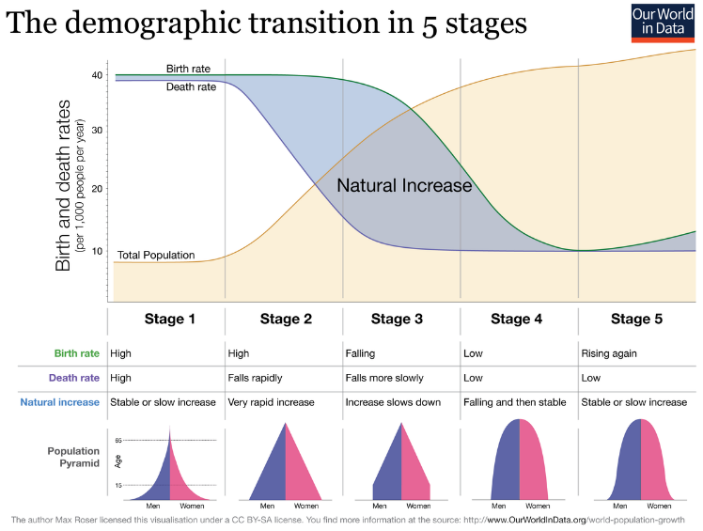
Interpret a Demographic Transition Model (Stages 1-5)
          - Stage 1 – crude birth rate is high and stable, while the crude death rate is high and fluctuating due to famine, disease, and war.
- Stage 2 – The death rate declines significantly, and the birth rate remains at the previous level. Infant mortality rate falls and life expectancy increases.
- Stage 3 – Social norms adjust to lower the level of mortality and the birth rate begins to decline. Life expectancy continues to increase and infant mortality decrease.
- Stage 4 – Both birth and death rates are low. Population growth is slow. Death rates rise slightly as the average age of the population increases.
- Stage 5 – Birth rate has fallen below the death rate, resulting in natural decrease. These populations are declining.
- Critics say that the DTM was largely based on Western Europe and cannot be applied to most of the world. The model presumes that all countries will eventually pass through all stages of the transition.
- Issues of ageing populations:
  - An ageing population is the rise in median age of a population. It occurs when fertility declines while life expectancy remains constant.
  - Those who are 85 years or older need expensive residential care.
  - Decline in workforce.
  - Increase in healthcare costs.
  - Increase in Dependency Ratio
  - Greater demand for healthcare services and retirements homes.
  - **However** : many older people make a big contribution to childcare by looking after their grandchildren. In addition, larger numbers of older people work as volunteers, for example in charity shops.
- Issues of youthful populations:
  - Strains education, healthcare, and food services
  - Lack of availability of jobs in the future
  - Present working population is unable to pay for schooling of the youthful population.
  - Ecological destruction in order to create more space for agriculture and accommodation.
- Know how the development of a country can affect the factors below.
  - Factors affecting decline in global infant mortality rate:
    - better nutrition
    - improvements in public health, with regard to water supply and sanitation
    - medical advancements
    - improvements in housing
    - introduction of better maternity conditions (maternity leave) for new mothers
  - Factors affecting change in life expectancy:
    - Life expectancy is affected by many factors such as: socioeconomic status, including employment, income, education and economic wellbeing; the quality of the health system and the ability of people to access it; health behaviours such as tobacco and excessive alcohol consumption, poor nutrition and lack of exercise; social factors; genetic factors; and environmental factors including overcrowded housing, lack of clean drinking water and adequate sanitation.

  - – Population Resource Relationship
- Carrying Capacity: The maximum number of people an area can sustain at a level of technological advancements. The higher the technology advancements leads to a larger carrying capacity.
- Overpopulation: an increase in population leads to a decrease in the quality of life. Population that is very large. A rise beyond the optimum population.
- Optimum Population: when population and resources are perfectly matched. Almost impossible to achieve but represents the highest quality of life. Allows for further exploration of a countries resources.
- Under population: a decrease in population equals a higher quality of life. The country or region that is not yet to an optimum population.
- To have food security is when all people at all times have access to sufficient, safe, and nutritious food to maintain a healthy and active life.
  - Food availability: sufficient quantities of food available on a consistent basis
  - Food access: having sufficient resources to obtain appropriate foods for a nutritious diet
  - Food use: appropriate use based on knowledge of basic nutrition and care, as well as adequate water and sanitation
- Causes and consequences of food shortages:

  - soil exhaustion
  - drought
  - floods
  - tropical cyclones
  - pests
  - disease
  - low capital investment
  - rapidly rising population
  - poor distribution and transport difficulties
  - conflict situations

- Agricultural technology (to aide in food security):
  - the development of high yielding seeds
  - genetic engineering
  - precision agriculture which is the integration of information to improve agricultural knowledge in addressing site specific production targets
  - employing advanced techniques to remediate land that has been damaged by poor agricultural practices
- Constraints on sustainable populations:
  - war : food water and other resources are deliberately destroyed to make life as difficult as possible for the opposing populations
  - trade barriers : reduces the export potential of poorer countries and hinders development
  - tropical storms are a major hazard and an impediment to development in a number of LICs such as Bangladesh and the countries of Central America and the Caribbean

  - – The Management of Natural Increase
Case Study - Managing Natural Increase in China - China has a population of one billion and has implemented the one-child policy. This policy has reduced population growth, but has caused demographic aging, unbalanced sex ratio, and social divide. The one-child policy has successfully prevented as least three-hundred million births which has led to economic growth. Despite China’s large landmass the best land is found in the east and south which results in high population density is in these areas. The balance between population and resources has led to recent worry, this concept has been debated since Confucius who believed population growth lowered output per worker, depressed the level of living, and produced strife. He believed that deviating from the ideal proportions between land and population would cause poverty and the government should enforce spreading people throughout the country. Between 1950 and 2014, the birth rate decreased from 43.8/1000 to 12/1000. From 2000 2010, China’s population increased by .57% a year. This was half the level of the previous decade and 1/5 of the level in 1970. The total fertility rate was 6.1 between 1965 and 1970 and progressively decreased to 1.6 in 2013. for people in the west, it’s often difficult to understand the all-pervading influence over society that A government can have in a centrally planned economy. Following the communist revolution in 1949, population growth was initially encouraged for economic, military, and strategic reasons. Sterilization and abortion were banned and families received payment for each child. By 1954, China’s population had reached 600 million and the government worried about this strain on resources. China’s first birth control program was established in 1956. Due to the government’s worry that progress of modernization would be hindered by labor shortages, births were once again encouraged. The shift lead to a famine which killed 20 million people. In 1979 the one child policy was established. As China’s estimated Optimum population was 700 million, many praised China’s initiatives. Controversy began as some praised the Chinese idea and others believed it violated civil liberties. Families in rural areas that obey the family planning rules get priority for loans and other aspects of aid. The one child policy has impacted urban areas as the traditional bias of desiring a son has been eroded. The policy has impacted the sex ratio which is currently 119 point to 100 girls. In 2008 a paper was published which stated that China had an estimated 32 million more men under 20 years old than women. Selective abortion has allowed for abortion to be carried out after prenatal screening. Gender discrimination has become an increasing issue. The disproportioned ratio would lead to many males not finding a female partner to marry and start a family with. China’s aging process is occurring quicker than most other countries due to the speed of its demographic transition. Care for the elderly will grow into a major problem. Decline in the supply of young labor has been a major factor in pushing up wages. The creation of the generation of children who are often viewed as spoiled and arrogant has resulted from the policy. In September 2015 the Chinese government announced it would relax the rules and allow all couples to have two children from March 2016.
TOPIC 5: Migration
  - – Migration as a Component of Population Change
- Types of migration
  - Migration: The movement of people across a specified boundary, national or international, to establish a new permanent place of residence.
  - International Migration: Migrants cross international boundaries
  - Internal Migration: Migrants move within the frontiers of one nation
  - Chain Migration: After one or a small number of pioneering migrants have led the way, others from the same rural community follow.
  - Relay Migration: At different stages in family’s life cycle different people take responsibility for migration in order to improve the financial position of the family.
  - Stepped Migration: The rural migrant initially heads for a familiar small town and then after a period of time moves on to a larger urban settlement.
  - Forced Migration: the individual or household has little or no choice but to move.
  - Voluntary Migration: The individual or household has a free choice about whether or not to move.
- Reasons for migration
  - Push Factors: Observations that are negative about an area in which the individual is presently living
  - Pull Factor: The perceived better conditions in the place to which the migrant wishes to go.
  - Intervening obstacles: Include distance, the means and cost of transport and legal restraints.
  - – Internal Migration
- Migration Patterns
  - National level: typically, rural to urban
  - Migration Patterns international: x origin to big city
  - The longer the distance the higher cost, likelihood for social change such as dialect or social organization of groups. May also lead to different ethnicities.
  - Urban to Rural Migration typically occur when urbanites return to their rural locations. Counter urbanization is not common in LIC’s
  - Rural to urban migration typically occurs from peripheral regions to economic core regions. The main migration streams are from culturally traditional areas to areas where rapid change is present.
  - Urban-Urban: Due to stepped migration up the urban hierarchy as migrants improve their knowledge base and financial position.
  - – International Migration
- Describe & understand voluntary and forced migration
  - Voluntary migration
    - Independent: decision made by individual
    - Dependent: collectively by household
- Forced Migration
  - Refugee
  - Internal displacement

  - – The Management of International Migration
- Impacts of international migration on:
  - Destination country

    - Increasing culture diversity
    - Bring new skills
    - Taking jobs
    - Tension
    - Change in ethnic balance
    - Growing population
    - Negative impact on environment

  - Country of origin (area people are leaving)

    - Remittance- income
    - Returning migrants bring back new... Ideas, skills, remittances
    - Old population
    - Agricultural output may suffer if labor level are really low
    - Brain drain effect - Skillful people are leaving

- CASE STUDY!!! Mexico and USA
  - Causes:

    - Unemployment/ underemployment
    - Family unification
    - Low income
    - Poor quality of life
    - Lack of opportunity

  - Characteristics: Guest Workers - Young Mexican men (braceros)
  - Effects on Source (MEXICO)

    - Reduced of unemployment
    - High value of remittances
    - Change of population pyramid
    - Brain drain effect
    - Returned migrants- different attitudes

  - Effects on Destination (USA)

    - Undermine opportunities of low-skilled US workers
    - Cost to taxpayers of illegal workers
    - Education
    - Emergency medical care
    - Economic crisis
    - Rise in unemployment by 10%
    - Harming environment
    - Threatened US values

TOPIC 6: Settlement Dynamics
  - – Changes in Rural Settlements
- WHY THERE ARE CHANGES
  - The economy of rural areas is no longer dominated by farming causing technology and service sector to increase
  - New uses of rural space such as recreation or tourism
  - The rural landscape has evolved into a complex multi-use resource causing the rural population to change
- ISSUES THE CHANGES RAISE
  - Due to counterurbanisation, areas affected by rural depopulation have diminished
  - Rural services have been on the decline thus affecting the quality of life
  - Local services no longer competitive
  - Different shopping and consumer patterns
  - Opportunity to access to better services

- IMPACTS OF INTERNAL MIGRATION

  - Change in settlement patterns
  - Mix of cultures
  - More competition
  - The switch of lifestyle

- CONSEQUENCES OF URBAN GROWTH

  - Higher water and air pollution
  - Increased traffic issues
  - Loss of agricultural capacity
  - Harmful effects on human health

- THE DIFFERENCE IN RURAL AREAS
  - HICs: lack of rural areas, mainly used for big time farming, much of HICs is very urbanized
  - MICs: a little more focus on rural areas, many people are migrating from rural area to more urban areas, but still people are transitioning away from farming practices
  - LICs: completely dependent on rural areas and their agriculture, rural areas is the base of the economy, little urbanisation, poor
- RURAL SETTLEMENT CASE STUDY - Mossi People of Burkina Faso
  - Live in small villages around Burkina Faso- West Africa
  - Each village has a hierarchical system that they feed into- very family oriented and homogenous
  - Development increased with the growth of Burkina Faso- the craftsmanship and art created by the Mossi people is often sold in the big city- farmers markets and flea markets
  - Subsistence Farming - millet and sorghum
  - This prevents development as they are unable to shift to a more productive crop
  - Only used for feeding themselves and their family- no long term benefits
  - Shifting to more productive crops
  - Working on more rural-urban migration people can improve their education and get jobs in the big city (with better pay)
  - The African Government can provide more funding to Burkina Faso to create better outreach and integration of the other villages (help to remove poverty from the entire area, not just targeting individual mossi groups)

  - – Urban Trends and Issues of Urbanisation
- DEFINE URBAN VOCAB:
  - Urbanization: increase in the proportion of people living in towns or cities as areas develop
  - Urban Growth: rate at which the population of an urban area increases as a result of urbanization
  - Suburbanization: outward growth of an urban development that may engulf surrounding villages and towns into a larger urban agglomeration
  - Counterurbanization: large numbers of people move from urban to rural areas
  - Re-urbanization: when people move back into inner city areas where people had previously moved from
  - Urban Renewal: process where an urban neighborhood or area is improved or rehabilitated
- PROCESS OF URBANIZATION
  - Typically, rural to urban due to economic factors as it is driven by social changes as a region develops and industrializes to provide better education, healthcare, and housing
  - Urbanization then often indicates a region that is transitioning from a lower stage on the demographic transition model to a higher stage
- CAUSES OF URBANIZATION
  - LEDCs: investment policies of central governments favor urban areas because it increases their global prestige, higher wages and employment protection benefits are introduced in urban areas, and their is greater access to education and healthcare in urbanized areas
  - MEDCs: there is less demand for locally grown food as consumers prefer imported goods and the investments of governments favor urban areas as it displays further development to remain competitive in the global market
- CONSEQUENCES OF URBANIZATION
  - LEDCs: the best economies of scale and agglomeration are offered in urbanized areas as well as the opportunities for industrial linkage with surrounding areas
  - MEDCs: better opportunities for industrial linkage with the already developed regions of the country as well as the opportunity of maximum effectiveness and lowered costs in terms of control over supply sources
- COMPETITION FOR LAND
  - The growth of urbanized areas = retail, industrial, and residential zones
  - Land closest to the hub of the urbanized area (CBD) = retail because shops and offices can afford more land with higher values
  - Land farthest from the CBD = residential because housing can only afford low land values
  - Land in between = industrial as industry cannot afford the highest land values
  - As the distance from the Central Business District increases, the competition for land decreases as land values decrease
- Urban renewal
  - Redevelops land that has been decaying or has atrophied over time - buildings are razed and rebuilt, increasing property value
  - Gentrification is seen in this practice as older properties which are valued less, gain property value due to the area’s prestige increasing. This causes families to be forced out of their homes as they can no longer afford their property.
  - Often caused De Facto segregation as African Americans who lived in these cities were forced out
- World City
  - A city that is a hub for the global economy. Trade and business often happen in these cities. Transnational corporation headquarters are usually centered in these
  - Examples: London, NYC, Tokyo, Mexico City, LA, Sydney, Houston, Frankfurt
- How and why World Cities grow
  - How: Competition between other major cities and World Cities cause the need for increased imports, transportation, and business to be dealt with in the cities. As more jobs arise in these areas, more people start to live in the surrounding areas, geographically increasing the size.
  - Why: The centralized market and typically affluent economy in the areas brings in more people. The more people there are, the more people can add to the economy. Again, competition is a main factor as each city wants to be the source for the best deals and trade.
- Development of world city hierarchy
  - The dominance of the centralized market
  - The prestige of the corporation headquarters within
  - The influence the city has over the world economy
  - The influence the city has over national trade and business deals
  - Importance of internal operations on external operations

  - – The Changing Structure of Urban Settlements
- Functional Zonation of Urban Areas: Definition: The division of the city into certain regions for certain purposes. 3 models where contrived in order to organize how the expansion of cities could be explained:
  - Concentric Zone Model:
    - The center of the model is the CBD (downtown): max accessibility for the urban area
    - ‘Zone in transition’: Has older private houses, attracted new comers to city because of low housing prices
    - ‘Zone of working-men’s homes’: oldest houses in the city, with stable social groups
    - ‘Residential Zone’: middle class, newest and largest homes
    - ‘Commuters Zone’: being the outer most ring of the concentric zone
  - Sector Model:
    - CBD (downtown): max accessibility for the urban area
    - High income houses developed around distinct physical or social attractions
    - Low income housing grew around unfavorable locations
    - This model emphasizes sectors being influences by transport routes

  - Multiple- Nuclei Model
    - Urban land use does not develop around a single center, but a number of centers (nuclei)
    - Nuclei range in duration of establishment, new nuclei can be established at anytime
    - Middle- and high-income house buyers have the ability to avoid industrial areas, ultimately making that an area taken over by poverty
    - Rapid urban expansion may result in the creation of a new nuclei (ex. New out-of-town shopping center
- Residential Segregation: The degree to which two or more groups live separately from one another, in different parts of the urban environment.
  - Factors that affect segregation: socio-economic classes, ethnic groups, and race
  - Processes influencing segregation:
    - Redlining: Practice by which banks, insurance companies, refuse or limit loans, mortgages, insurance, within specific geographic areas, especially inner-city neighborhoods.
    - This discriminatory practice led to trapping those further into poverty with no way out
    - Minorities targeted by policies makers mapped out green and red neighborhoods so that economic prosperity would limit itself to primarily white house owners
- Characteristics of the Central Business District (CBD)
  - core of an urban area and exhibits the highest land value
  - focus of public transport systems and the most accessible area in a city and has high pedestrian flow
  - vertical zoning is present in the core in response to land price and space
  - high land prices lead to low residential areas in the core and is mainly occupied by business & retail
  - the CBD contributes to the economic health of an urban area
  - urban development plays into the change a CBD experiences
- Spatial Competition in in Urban Areas - The high level of competition for land in urban areas has continuously pushed up prices to prohibitive levels for manufacturing industry in many towns and cities
- Factors affecting the location of urban activities
  - Market forces- demand and supply of land dictates the price of these activities
  - Location or central government planning decisions
    - Planners can overrule market forces
    - Governments can decide constraints on locations of certain buildings and housing
  - Can also issue compulsory purchase orders
  - Manufacturing, office functions, education, health, leisure, and open space all affect urban activities.
- How urban locations change over time
  - Manufacturing
    - Deindustrialization in developed countries caused removal of factories
    - Land in the urban core is often too small or unfit for modern manufacturing
    - High competition results in prices rising for manufacturing and industry
    - Economic planning and urban planning policies have pushed factories out
  - Retailing
    - Suburban retail centers develop to accommodate for sprawling urban population
    - Retail parks require a lot of area, making the =m more suitable for outside the crammed cities.
    - Online shopping has decreased the popularity of certain types of shops
    - Large shopping centers typically found on city edges in areas of high demand
  - Other services
    - Health: More investment in larger hospitals which are more spread out
    - Education: Secondary education has become more spread out and larger as well
  - Sports: Movement for inner city to suburban areas due to shortage of kids
  - Land uses that require large sites are often found on the rural-urban fringe (ex: golf courses, theme parks, racetracks, etc.)
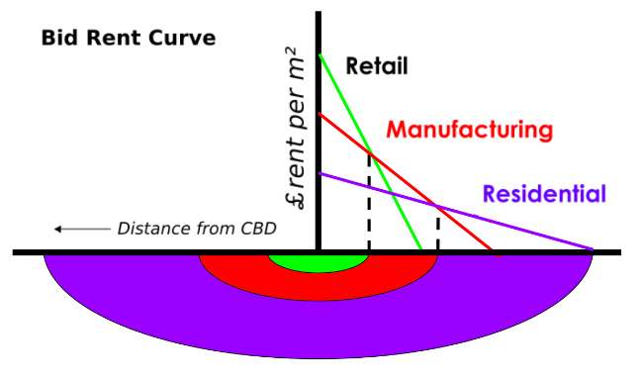
- Bid-Rent Theory – Ideology of high competition and high priced pieces of land centralized (town center). As distance from central increases, industry is heavier, until cheaper land is available where residences reside.

6.4 Case Study: Heliopolis and development of favela
- Background: Heliopolis is one of the largest slums in Latin America.
  - The slum then established into a favela (shanty town/squatter settlement) through people building shacks after land invasion from Brazil and people coming to play football.
  - The population is now over 100,000 people and ranges from severe and semi-poverty with a limited access to facilities such as libraries.
- Development: Population growth led to dirt roads being replaced by asphalt and paved routes, drug gangs gaining power, as well as violence and murder increasing.
  - Relating to urban infrastructure 100 percent of Heliopolis gained street lightening and water connection, 77 percent garnered sewerage connection, a bus stop was established, and Wi-Fi was introduced.
- Impacts: Due to the rapid nature of the growth the construction was fragile. This led to the fire that occurred in July of 2013 leaving 900 people homeless and killing three people.
  - Roads are also very narrow as the structure if the region was not planned.
  - Poor quality of housing
- Solutions: ActionAid pressed City Hall for housing improvements as they asked for homes to be safely constructed and for poor people to not be exploited.
  - UNAS: “the need for rehousing of people was established, but nothing was done in two years and now they want to do it in a week”
  - Ruy Ohtake’s plan to ‘rethink Brazil’s favelas’ worked to create a uniform street color scheme, the Heliopolis Housing Project, sanitary improvements, and apartments.

- Population
- 4.1 Natural increase as a component of population change
  - Distinguish the difference between distribution vs. density

- Population  - 4.1 Natural increase as a component of population change |  |  | - describe and understand the factors (social, economic, environmental and political) affecting levels of births and deaths, fertility and mortality  - interpret age/sex structure diagrams  - understand how a population group is made up i.e. its structure, and know some of the component parts:  - age  - gender  - dependency and dependency ratio  - dependency ratio
- 4. Population | - 4.2 Demographic transition |  | - know and understand how and why birth rates and death rates change over time  - draw, interpret and explain the demographic transition model through stages 1–5  - be critical in describing and understanding the model’s uses, limitations and extensions  - know and understand issues of youthful and ageing populations  - describe and understand links between population and development as shown through changes in infant mortality rate and life expectancy over time.
- 4. Population | - 4.3 Population- resource relationships |  | - understand what is meant by food security  - know and understand the causes and consequences of food shortages  - know and understand how resource development, e.g. food production, relates to technology and innovation  - know and understand how constraints, e.g. war, climatic hazards, link to population and resources  - understand the concept ‘carrying capacity’  - explain and look critically at the concepts of:  - overpopulation  - optimum population  - underpopulation
- 4. Population | - 4.4 The management of natural increase  - Case Study |  | - know and understand in detail a case study of one country’s population policy regarding natural increase (population increase or decline). In this you should:  - know and understand how the country attempts to control population (the management policies)  - know how and why this country faces difficulties in managing its natural increase  - understand how the policies attempt to solve these problems  - critically judge the success level of these policies
- 5. Migration | - 5.1 Migration as a component of population change |  | - describe and understand the types of migration (excluding all movements of less than one year’s duration)  - understand the reasons for migration  - economic, social, political, cultural, racial,  - push factors, pull factors  - describe and understand the ways by which people migrate, i.e.  - the processes (how migration is achieved – including chain migration)  - the patterns of migration (spatial movements of migrants – and how distance and age affects these patterns )  - understand the effects of constraints, obstacles and barriers, e.g. distance, cost, national borders, language
- 5. Migration | - 5.2 Internal migration (within a country) |  | - describe and understand rural-urban and urban-rural movements  - causes  - effects on areas people leave (source areas)  - effects on areas people go to (receiving/destination areas)  - include the effects on population structures  - describe and understand how migration can occur in steps from villages to small towns, from one town to another and on to cities (stepped migration) and within urban to urban movements  - describe and understand intra-urban movements (within urban areas) – their causes and impacts
- 5. Migration | - 5.3 International migration |  | - describe and understand voluntary and forced (involuntary) movements  - causes of international migration, e.g. economic  - patterns of international migration, e.g. refugee flows  - impacts on areas people leave (source)  - impacts on areas people go to (receiving/destination areas)
- 5. Migration | - 5.4 The management of international migration  - Case study |  | - describe and understand in detail one example of an international flow of people  - causes  - character  - scale  - pattern  - effects on source  - effects on receiving/destination area
- 6. Settlement dynamics | - 6.1 Changes in rural settlements  - Case study |  | - understand why there are changes taking place in rural settlements in LICs HICs and MICs  - the contemporary (up to date) issues the changes raise (include depopulation service provision)  - the impacts of internal migration (rural-urban and urban-rural migration)  - the consequences of urban growth  - describe the difference in rural areas between in HICs LICs and MICs  - You need to have detail about a rural settlement (village or hamlet) or a rural area which includes:  - show how there is development and growth (or decline)  - the issues of its development and growth (or decline)  - evaluating the response to these issues (depending on which you choose, the changes to consider will be slightly different or additional, such as inroads by industry, recreation, transport, etc.)
- 6. Settlement dynamics | - 6.2 Urban trends and issues of urbanisation |  | - In relation to HICs MICs and LICs  - define:  - urbanisation  - urban growth  - suburbanisation  - counterurbanisation  - re-urbanisation  - urban renewal  - understand the process of urbanisation  - causes of urbanisation  - consequences of urbanisation  - conflicting demands for land (competition for land)  - understand urban renewal  - understand the concept of a world city  - understand how and why world cities grow  - understand the development of a hierarchy of world cities (what it is based on, how cities are ranked, etc.)
- 6. Settlement dynamics |  | - 6.3 The changing structure of urban settlements |  | - have a basic knowledge of the major land-use models (e.g. Burgess, Hoyt, Mann)  - understand the social, economic, environmental and political factors (including planning) which affect the location of activities.  - Describe and understand how urban locations change over time for retailing, services, and manufacturing  - describe and understand the character of the Central Business District (CBD) and the changes taking place there  - understand the competition for space (spatial competition) in urban areas  - the concept of bid rent  - functional zonation in urban areas  - describe and understand residential segregation  - causes (income and race/ethinicity)  - processes (operation of the housing market, influence of family and friends, culture and planning)
- 6. Settlement dynamics |  | - 6.4 The management of urban settlements  - Case study |  | - you need to have detail on urban settlements which show the challenges and solutions for each of the following:  - A shanty town (squatter settlement) in a HIC or LIC  - challenges of a shanty town  - evaluating attempted solutions  - (2) providing infrastructure (either power or transport) for any city  - challenges of providing infrastructure (either power or

